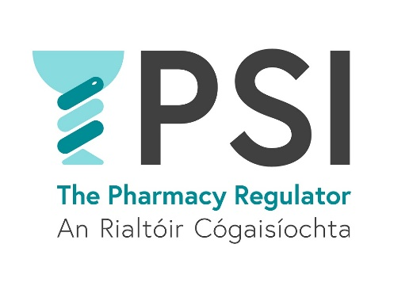

Self-Assessment for Pharmacists Delivering COVID 19 Vaccines
Pharmacists are asked to reflect, self-assess, and evaluate their training and competence in order to have the necessary skills and knowledge to safely deliver the associated COVID 19 vaccines. This form should be completed and kept as part of the pharmacists records.
Pharmacist Name:
PSI Registration Number
Step 1 | Descriptor |  | Yes
 | I am familiar with and comply with the Legislation which allows pharmacists who have completed accredited and approved training to administer vaccines set out the Medicinal Products (Prescription and Control of Supply) Regulations 2003 (as amended).
 | I have completed an accredited and approved Medicines Administration (Parenteral) Training Programme and hold a valid certificate for this training programme.
I understand the need to repeat the Medicines Administration (Parenteral) Training Programme if:
- I intend to deliver a vaccine or emergency medicine via an injection route which I have not previously administered
or
- I intend to deliver a vaccine or emergency medicine via an injection route which I have neither practised (i.e. administered to a patient) nor been trained in* in the previous 12 months (or previous flu season)

(*trained in means completion of the Medicines Administration (Parenteral) Training Programme.)
Step 2 | I am competent in safe injection technique for the injection routes I intend to deliver vaccinations and/or emergency medicines
 | I have a valid certificate for CPR (Adults and Children)
 | I have a valid certificate for the Responding to an Emergency and Management of Anaphylaxis (RESMA) training module
 | I have a valid certificate for the Delivery of a Vaccination Service training module
I hold a valid certificate confirming I completed the approved HSEland training that will allow me supply and administer the following vaccines:
• Comirnaty (Pfizer/BioNTech)
• Moderna
• Astra Zeneca
- Janssen
 | I am familiar with the Summary of Product Characteristics (SPC) for each vaccine(s) I intend to administer
 | I am familiar with and comply with the current, relevant, National Immunisation Advisory Committee (NIAC) ‘Immunisation Guidelines for Ireland’.
 | I am familiar with and comply with the current National Immunisation Office (NIO) Guidelines
 | I have completed the mandatory reading for vaccinators as provided on the approved HSELanD training
 | I will ensure that I am aware of any changes to legislation, training or guidance and will take steps to update my knowledge and skills as applicable
 | I am aware of the practice, procedures and governance framework underpinning the vaccination activities of the vaccination centre or retail pharmacy business, where I will be administering COVID 19 vaccinations
Step 3 | I am satisfied that I possess the requisite theoretical knowledge and practical skills to safely administer COVID- 19 vaccines in accordance with the legislative requirements and all relevant procedures at the vaccination centre/retail pharmacy business. I understand, in accordance with the Statutory Code of Conduct for Pharmacists that I am personally and professionally responsible for my own acts or omissions in this regard.  ________________ __________________  Signature Date

Useful References (This list is not exhaustive)
- When performing your self-assessment, you may need to refer to the relevant sections of legislation and PSI Guidance. You can access pharmacy and medicines legislation through www.irishstatutebook.ie or on the PSI website www.psi.ie.
- The National Immunisation Advisory Committee (NIAC) ‘Immunisation Guidelines for Ireland’ are available through the National Immunisation Office (NIO) website www.immunisation.ie
- The Summary of Product Characteristics (SPC) for each vaccine and/or emergency medicine is available via the Health Products Regulatory Authority (HPRA) website www.hpra.ie.
- The validity of training modules are outlined on the PSI website and/or by the training provider in the case of CPR certificates.

