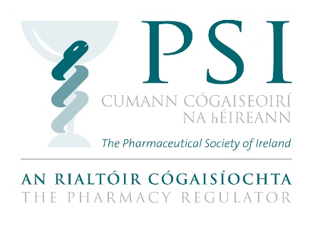

Application Form for PSI Audit and Risk Committee
May 2019

The PSI is inviting interest from candidates for appointment to its Audit and Risk Committee.

Instructions

- Please complete all sections of this application form.

- The completed application form may be sent by email to eanna.olochlainn@psi.ie or by post to: Éanna $Ó$ Lochlainn, Governance and Planning Officer, PSI House, 15-19 Fenian Street, Dublin 2, D02 TD72 so that it arrives by 11 June 2019.

- Please note the PSI will not accept applications which are not submitted on this form.

SECTION 1: PERSONAL DETAILS

Please fill in all fields
Title: | Surname: |  | Forename:
Address:

Phone: |  | Email:
Country of Residence:

SECTION 2: COMPETENCIES

Please reflect on the competencies set out in the information booklet, and provide your responses in the sections below. Please ensure you provide sufficient detail to demonstrate your experience and knowledge. Aim to complete each field in 250 words, or less.

- Please outline your relevant experience in one, or more, of the following areas: Finance, accountancy or audit; risk management; governance; the public sector environment including public accountability structures.

- Please give an example that demonstrates your ability to work collaboratively and constructively with others.

- Committee members are required to have good interpersonal, oral and written communication skills. Please provide an example which demonstrate how you meet this requirement.

- Briefly outline any additional contributions/expertise you wish to highlight in relation to membership of the Audit and Risk Committee. You may wish to outline your understanding of public interest, and the PSI’s role as a regulator, highlight your previous or current experience, or your service on other similar committees or boards.

SECTION 3: DECLARATION

I hereby certify and declare that:

- All the information I have provided on this application form has been honestly and accurately articulated to the best of my knowledge and belief.
- I do not know, or am not aware, of any conflict, or potential conflict of interest, which would prevent my appointment as a member of the PSI Audit & Risk Committee.
- I am computer literate, and have sufficient information technology (IT) skills, to conduct Committee business digitally, or by electronic means, when required to do so, and if necessary, work in a paperless environment.

Name: ____________________________________________

Date: _____________________________________________

Any person found to have given false information or to have wilfully suppressed any material fact will be disqualified.

Please see the data protection notice contained in the Information Booklet for the PSI Audit and Risk Committee. The PSI will process any personal data in relation to your application in accordance with Data Protection legislation. More information is available in our Data Protection Statement.

