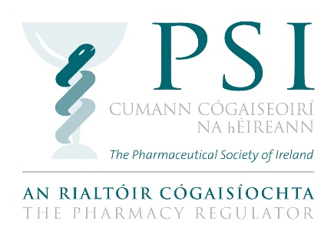

Application Form for Accreditation Panel
August 2019

The PSI is inviting applications from interested candidates for appointment to a panel for future accreditation teams to evaluate and review national pharmacy degree programmes through an accreditation process.

Instructions

- Please complete all sections of this application form.

- Please reflect on the required competencies set out in the information booklet and provide your responses in the sections below. Please ensure you provide sufficient detail to demonstrate your experience. Aim to complete each field in 500 words, or less.

- Please note the PSI will not accept applications which are not submitted on this form, and additional documents should not be enclosed with this form.

- The completed application form may be sent by email to andrea.boland@psi.ie or by post to: Andrea Boland, Education Standards Officer, PSI House, 15-19 Fenian Street, Dublin 2, D02 TD72 so that it arrives no later than close of business on Friday, 30 August 2019.

SECTION 1: PERSONAL DETAILS

Please fill in all fields
Title: | Surname: |  | Forename:
Address:

Phone: |  | Email:
Country of Residence:

Place of employment:

Current position:

SECTION 2: COMPETENCIES

Please reflect on the competencies set out in the information booklet and provide your responses in the sections below. Please ensure you provide sufficient detail to demonstrate your experience and knowledge. Aim to complete each field in 500 words, or less.

- Please indicate your relevant experience in one, or more, of the following areas by ticking the applicable boxes below.
☐ Quality Assurance
☐ Regulation
☐ Accreditation
☐ Risk
☐ Governance
☐ Patient Advocacy/Public interest representation
☐ Practising pharmacist in Ireland and/or acting as a tutor pharmacist/preceptor
☐ Development/design/accreditation of pharmacy or other education programmes
☐ Monitoring and review of pharmacy or other education programmes
☐ Head of School /Head of Faculty/Head of Department
☐ Programme manager/leader
☐ Dean of students, or equivalent
☐ Teaching and Learning

Please elaborate further on your relevant experience in the text box provided:

- Decision Making Skills: Please give an example of how you have analysed large amounts of information to make a fair and reasoned decision.

- Teamwork: Please give an example that demonstrates your ability to work collaboratively and constructively with others.

- Briefly outline any additional contributions/expertise you wish to highlight in relation to your application to become a member of an accreditation team. You may wish to outline your understanding of regulation in the context of the PSI’s role as pharmacy regulator, your understanding and experience in the delivery of educational programmes, or development of education standards, your communication and interpersonal skills, or highlight any additional relevant experience, including service on other similar teams or committees.

SECTION 3: DECLARATION

I hereby certify and declare that:

- All the information I have provided on this application form has been honestly and accurately articulated to the best of my knowledge and belief.
- I am computer literate, and have sufficient information technology (IT) skills, to participate in online meetings, conference calls, if required to do so, and if necessary, work in a paperless environment.

Name: ____________________________________________

Date: _____________________________________________

Any person found to have given false information or to have wilfully suppressed any material fact will be disqualified.

Please see the data protection notice contained in the Information Booklet. The PSI will process any personal data in relation to your application in accordance with Data Protection legislation. More information is available in our Data Protection Statement.

